**BSc INTERIM REPORT**  
  
Submitted for the  
BSc Honours in Computer Science with Games Development  
  
January 2009  
  
**Particle System for the PSP**  
  
by  
  
**Jamie Sandell**

**Contents**

* 1 – Report Introduction and Project Introduction
  + 1.1 – Report Introduction
  + 1.2 – Project Brief
* 2 – Project Aims
* 3 – Background Context
  + 3.1 – What is a Particle System?
  + 3.2 – How a Particle System Works
  + 3.3 – Why a Particle System?
  + 3.4 – Porting to the PSP
  + 3.5 – Efficiency
    - 3.5.1 – Inlining
    - 3.5.2 – Virtual Methods/Templates
    - 3.5.3 – Constructors/Destructors
    - 3.5.4 – Avoiding New and Delete
    - 3.5.5 – Vertex Arrays
  + 3.6 - Alternatives to Achieving the Goal
  + 3.7 – Ethical Issues
    - 3.7.1 – Process
    - 3.7.2 – Product
* 4 – Project Appraisal
* 5 – Revised Time Plan
* 6 – Background References
* 7 – Appendix
  + 7.1 – Appendix I
  + 7.2 – Appendix II
  + 7.3 – Appendix III
  + 7.4 – Appendix IV
  + 7.5 – Appendix V

**1 – Report Introduction and Project Introduction**1.1 – Report Introduction  
  
The purpose of this report is to clearly outline the Particle Engine for PSP project and to report the progress so far, highlighting any problems and/or setbacks that have thus far occurred. The report shows the initial specification, any changes and modifications made up to this point, the aims, and background context of the project.  
  
1.2 - Project Introduction  
Project Code: JHP1  
Title: Particle Engine for PSP.

Specification:  
This project is to produce a particle engine and tool for use on the PSP development kit. This will require the student to use an industry standard PSP development kit and SDK. The project is suitable for a proficient programmer and is ideal for someone hoping to work in the games industry.

**2 – Project Aims**The ultimate aim and goal of the project is to design and create a fully working particle engine and tool for the PSP development kit. The first piece of analysis that must be done is to actually discover not only just what a particle system is and how a particle system works, but, also, why such a system is required. On-top of this the question must be raised - *how can the project be incorporated onto the PSP and how can it run efficiently on the hardware that the PSP offers*. A broad overview of how this can be achieved must be supplied. Finally any alternatives to achieving the intended project must be touched upon.  
  
**3 – Background Context**  
  
3.1 - What is a Particle System?  
  
A particle system is a “method for modeling fuzzy objects such as fire, clouds, and water. Particle systems model an object as a cloud of primitive particles that define its volume.” (Reeves, 1983, p 1).  
  
3.2 - How a Particle System Works  
  
There are many different approaches to a particle system, however, they all work on the same underlying basic principles, i.e.:

* The particle is generated by an emitter (see Appendix II)
* It’s new position is calculated
* Render the particle
* If it’s at the end of its lifespan it is removed, if appropriate it is reinitialised.

It is how the particle engine does this that makes the effects very different from a different effect, e.g. an explosion effect compared against a rain effect, these effects are completely different but are in fact created using the exact same principles. For instance the emitter can be changed to any emitter type wanted. The calculation of the particle’s new position can involve physics based simulation or stochastic (“*The most common choice is to implement some kind of dynamics to the particles so they mimic real-world phenomena.*”(Dalmau)). Then the particle engine renders the particle, this can be anything that the graphics library supports, e.g. a point or a triangle strip.  
  
3.3 - Why a Particle System?  
  
Why would someone need to program a formal algorithm to create such visual effects, why can’t conventional tools (e.g. Maya 3D) be used to create such an effect and animate it? Well this is answered and explained perfectly by Sabo in his article, he states, “*Particles making up the system are non-static unlike standard geometry objects. Particles are born, they change over time, and then die off. A key point regarding particle systems is that they are chaotic. Instead of having a completely predetermined path, each particle can have a random element, called a stochastic component, which modifies its behavior. This random element is, in fact, the main reason why particle systems are so good at reproducing realistic effects.*”(Sabo).  
  
3.4 - Porting to the PSP  
  
Porting the project to the PSP will not be too difficult, however, converting some graphical commands (OpenGL) will require converting the commands to their equivalent using a graphical library on the PSP.  
The biggest challenge with porting the engine will be getting it to run on the PSP efficiently, it must be kept in mind that the PSP is a handheld device, and as such, when compared to a cutting edge PC, or even an average PC it is lacking in hardware capabilities (See Appendix I). This actually poses a big challenge because a particle system can be displaying literally thousands of particles on the screen at any given timeframe, and not only just drawing them but also calculating their positions.

3.5 – Efficiency  
  
3.5.1 - Inlining  
Efficiency is a big issue for the project deliverable (see 3.4 – Porting to the PSP).  
One way to keep the program efficient is to make use of inlining where appropriate, such as inlining singleton methods (methods which are only called from one place in the program), because that will not increase the program size but will increase the program speed. Also small methods, such as accessors will be inlined, however excessive inlining can dramatically increase the execution speed of the program because of a resulting lower cache hit rate. For methods that aren’t too obvious whether or not they should be inlined test samples of the code will be ran, timing inlined and non-inlined versions.  
  
3.5.2 – Virtual Methods/Templates  
Virtual methods will be avoided because as Giplin clearly highlights:  
*“Virtual functions negatively affect performance in 3 main ways:*

1. *The constructor of an object containing virtual functions must initialize the vptr table, which is the table of pointers to its member functions.*
2. *Virtual functions are called using pointer indirection, which results in a few extra instructions per method invocation as compared to a non-virtual method invocation.*

*Templates can be used to avoid the overhead of virtual functions by using a templated class in place of inheritance. A templated class does not use the vptr table because the type of class is known at compile-time instead of having to be determined at run-time. Also, the non-virtual methods in a templated class can be inlined.  
The cost of using virtual functions is usually not a factor in calling methods that take a long time to execute since the call overhead is dominated by the method itself. In smaller methods, for example accessor methods, the cost of virtual functions is more important.”*3.5.3 – Constructors/DestructorsGiplin also makes a very valid efficiency point on Constructors and Destructors:  
*“The performance of constructors and destructors is often poor due to the fact that an object's constructor (destructor) may call the constructors (destructors) of member objects and parent objects. This can result in constructors (destructors) that take a long time to execute, especially with objects in complex hierarchies or objects that contain several member objects. As long as all of the computations are necessary, then there isn't really a way around this. As a programmer, you should at least be aware of this "silent execution".*

*If all of the computations mentioned above are not necessary, then they should be avoided. This seems like an obvious statement, but you should be sure that the computations performed by the constructor that you are using is doing only what you need.  
Objects should be only created when they are used. A good technique is to put off object creation to the scope in which it is used. This prevents unnecessary constructors and destructors from being called.  
Using the initializer list functionality that C++ offers is very important for efficiency. All member objects that are not in the initializer list are by default created by the compiler using their respective default constructors. By calling an object's constructor in the initializer list, you avoid having to call an object's default constructor and the overhead from an assignment operator inside the constructor. Also, using the initializer list may reduce the number of temporaries needed to construct the object.”*  
3.5.4 – Avoiding New and Delete  
It is a well known fact that allocating and freeing memory is an extremely slow process. Therefore it is imperative that, the re-spawning and killing of particles algorithms are scrutinised in-depth and made as efficient as possible. Dalmau explains that “*freeing memory each time a particle dies (or allocating memory for newborn particles) can have a significant performance hit, especially in those systems with large particle numbers or short life spans.”*The solution is to use arrays, because arrays provide the most linear access to the available data. Accessing the data linearly helps with caching, and as such, speeds up the code; however, there is a problem with this solution, and that is, reallocating arrays can be costly. The way to handle this problem to the solution is, implement some kind of memory management. How this will work is, initially, a single large block of memory will be allocated. I will store a pointer to the beginning of the allocation, a pointer to the very end of the allocation, and finally, a pointer to the next free space in the array.  
For example:  
After the block of memory has been allocated, both the start and end pointers will point to the start of the block since it’s empty. When a new element is added to the array, it is added where the last pointer is currently referencing, and then move the last pointer to the next memory location.  
As a result, if we want to remove an item from the array, then, all that has to be done is to simply copy the last element over the element to be removed, and move the last pointer back an item in the array.  
To surmise, using this technique all particles are maintained tightly packed at the beginning of the array with no gaps. In addition adding and removing particles is possible without the overhead of memory allocations. One slight problem is that we must not go above the static array allocation, but that is a small price to pay for the huge efficiency gain.  
  
3.5.5 - VertexArraysIn OpenGL there is a standard drawing technique which is:  
*glBegin(<PrimitiveType>);  
glEnd();*  
However this is an inefficient method for drawing thousands of particles. A much more efficient drawing routine is to make use of glDrawArrays. Since the particles are all nicely packed into one place, vertex arrays can be used to render the data. To do this we need to give the address of the first data element in the array. We also need to specify a stride parameter, i.e. the number of bytes between each data element. In this case, each position is seperated by another particle. The same is true of the colours.  
  
3.6 - Alternatives to Achieving the Goal  
  
Classically there are two methods of achieving the goal, the first is to code the particle system as a class hierarchy with ParticleSystem as an abstract class and new particles effects (e.g. fire) deriving via inheritance from this parent.  
The second alternative is to “*create a deep, complex particle system class, where individual systems are nothing but data-driven objects that*

*parameterize the class in many ways.*” (Dalmau).  
The plan of action for the project is to actually utilise both methods to achieve the project’s goal. The second method will be utilised first to create the editor (which will be used on a PC); this method is chosen for the editor because once an effect has been edited it will be easy to update the display to show the new particle effect (e.g. a switch statement to select the kind of emitter to use). The editor will then write the effects to a new file which will be in the form of a specified class framework.  
The first method will be the one actually used on the PSP to show the particle effects in action. This method has been chosen for this task because when in a game environment, or any big project environment, it is best to use an Object-Orientated approach as it becomes more manageable and easier to understand (easier to abstract and view high-level concepts).3.7 – Ethical Issues3.7.1 – ProcessThis project and all its operations are been conducted in an ethical manner. The IPR of others’ ideas have been respected greatly, any influences have been correctly citated.  
I have been honest in assessing and reporting my progress and in future planning of the project.  
I have given full compliance with recognised procedures.  
  
3.7.2 – Product  
My product can potentially affect my professional standing, if it fails then it could, conceivably, be the failing point of my degree. On the flip-side if it succeeds then it can only complement my professional standing, e.g. achieving my degree.  
There are no reliability/safety issues for users/clients/society at large.  
Legitimacy of actions available through the proposed system/project are wholly legal and ethical.  
  
4 – Project Appraisal  
  
At the time of writing this, (20/01/2009), the project is currently 15 days behind schedule. This is mostly due to other university pressures and deadlines such as exams and ACWs. Another contributing factor to this is that the particle system has gone through a code overhaul to make it much more efficient. It is much more efficient but I have come across problems when implementing the glDrawArray function when using primitives that aren’t of the type POINTS. The solution has not yet been discovered but I am of upmost confidence that it will be soon. Once that has been sorted, porting to the PSP will begin. The time that has been lost has not been a disaster of any accord, in fact, it was time spent learning and was a good thing not a bad one. I am confident that the project will be completed, and that it will be completed on time (Week 8 of Semester 2).  
See the original time plan (Appendix III), original task list (Appendix IV), and revised time plan (Appendix V) for more information.  
  
**5 – Revised Timeplan**#1 Initial Report  
A report outlining the ultimate aims and goals of the project accompanied by a plan and timescale.  
***Duration – 9 days.***#2 Research and Design  
Continue with background research and design the system at a high level.  
***Duration – 3 days.***#3 Prototyping  
Produce a prototype of the project software and assess it externally.  
***Duration – 1 day.***#4 Design  
Go back to the initial design document/(s) and alter according to feedback.  
***Duration – 1 day.***#5 Prototyping  
Alter the prototype accordingly.  
***Duration – 1day.***#6 Unit Implementation  
Code the necessary units.  
***Duration – 74 days.***#7 Unit Testing  
Test all units extensively (white box and black box testing).  
***Duration – 73 days.***#8 Unit Integration  
Integrate the necessary units.  
***Duration – 5 days.***#9 Integration Testing  
Test the integration extensively (white box and black box testing).  
***Duration – 5 days.***  
  
#10 Interim Report  
The interim report is essentially a progress review including any and all revisions, updates, and modifications that need addressing at this stage of the project.  
***Duration – 14 days.***  
  
#11 Final Report  
The final report is and all encompassing document of everything that I have done and achieved during my final year project.  
***Duration – 60 days.***  
  
#12 Project Appraisal  
This is a review of how far successfully I have managed my project and my time.  
***Duration – 14 days.***#13 Presentation  
Preparing and executing the presentation of my final year project.  
***Duration – 28 days.*6 - Background References**  
  
Lander J, 1998, *The Ocean Spray in Your Face* [online], Available: <http://www.darwin3d.com/gamedev/articles/col0798.pdf> [Accessed 16th October 2008].  
Dalmau DSC, 2003, *Core Techniques and Algorithms in Game Programming*, New Riders Publishing.  
Reeves TR, 1983, Particle Systems – *A Technique for Modeling a Class of Fuzzy Objects*, SIGGRAPH [online], 17(3), p359. Available: <http://www.lri.fr/~mbl/ENS/IG2/devoir2/files/docs/fuzzyParticles.pdf> [Accessed 16th October 2008].  
Zhang J, Angel E, Alsing P, Munich D, *An Object-Orientated Particle System for Simulation and Visualization* [online], Available: <http://www.cs.unm.edu/~treport/tr/01-06/particle.pdf> [Accessed 17th October 2008].  
VDB John, 2000, *Building an Advanced Particle System* [online], Game Developer, Available: <http://www.mysticgd.com/misc/AdvancedParticleSystems.pdf> [Accessed 18th October 2008].  
Molofee J, *Lesson: 19* [online], Available: <http://nehe.gamedev.net/data/lessons/lesson.asp?lesson=19> [Accessed 17th October 2008].  
Allen M, *Particle Systems* [online], Available: <http://web.cs.wpi.edu/~matt/courses/cs563/talks/psys.html> [Accessed 17th October 2008].  
Latta L, 2004, *Building a Million-Particle System* [online], Available: <http://www.gamasutra.com/view/feature/2122/building_a_millionparticle_system.php> [Accessed 22nd October 2008].  
Sabo M, *Improving advanced particle system by adding property milestones to particle life cycle* [online], Available: <http://www.cescg.org/CESCG-2004/web/Sabo-Miroslav/> [Accessed 22nd October 2008].  
Giplin A, *C++ Performance Tips* [online], Available: <http://www-2.cs.cmu.edu/~gilpin/c%2B%2B/performance.html> [Accessed 12th January 2009].

**7 - Appendix**7.1 - Appendix I  
  
PSP Hardware Specifications

## CPU

* Allegrex CPU
  + MIPS r4000 32-bit core 1-333mhz
  + 16kib I-Cache & D-Cache
    - 64-byte line length
    - 2-way set associative, LRU
  + No TLB
  + 7-stage pipeline
  + 32 32-bit registers
  + FPU (COP1)
    - 32-bit single precision
    - 32 32-bit registers
    - [IEEE 754](http://en.wikipedia.org/wiki/IEEE_754) compliant
    - Sqrt (28 cycles), div(28 cycles), most others 1 cycle
  + VFPU (COP2)
    - Vector FPU “Macromode only”
    - Designed for vector and matrix ops
    - 128 32-bit registers
      * Reconfigurable as scalar, vector or matrix
      * IEEE 754 Single precision float
    - Can also handle 32-bit int, 16-bit int, 8-bit int, half float
    - vmmul.z vd, vs, vt - 4×4 matrix/vector multiply, 22 cycles
* Media Block CPU
  + MIPS r4000-based core
  + 2MB Embedded DRAM
  + VME - Virtual Mobile Engine
    - Reconfigurable processor to decode audio & video
    - ATRAC3plus & MP3 for music
      * ATRAC3plus & ADPCM for games but not MP3 due to licensing issues
  + AVC H.264 engine
    - MPEG-4 Hardware accelerator
    - Up to 720x480x30fps
      * Libraries support 480x272x29.97fps

## Bus

* Main bus shared by CPU and Graphics Engine
* CPU only has level-1 cache, recomend minimizing memory usage
* Cache miss ~70 cycles
* VRAM read ~44 cycles
  + contention with GE
* Scratchpad read ~38 cycles

## Graphics

* Graphics Engine (GE)
  + 2MB Embedded DRAM
  + Supports Lighting, skinning (8 weights), morphing, subdivision, pixel operations
  + Operates at bus speed (default 111mhz)
  + 3.5GB/s Bus bandwidth
  + 444 Mpixels/sec fill rate
  + 23 Mploys/sec T&L

## Storage

* UMD
  + [UMD 1.8 GiB DISC](http://www.ecma-international.org/publications/standards/Ecma-365.htm)

## Ports

* Serial-Port (RS-232)
  + <http://mc.pp.se/psp/phones.xhtml>
* USB-Port

7.2 - Appendix II  
  
  
“*Particles are created at some kind of emitter, which initializes their parameters. If we want our system to behave in any interesting way,*

*the key is to generate each particle with slightly different initial values, so the behavior rules (which are shared by all particles) make each one look like a unique element.*” (Dalmau)

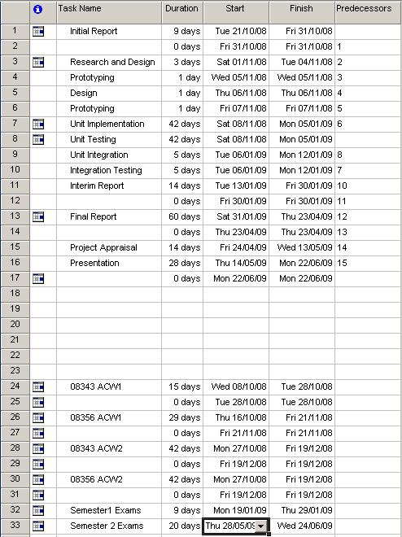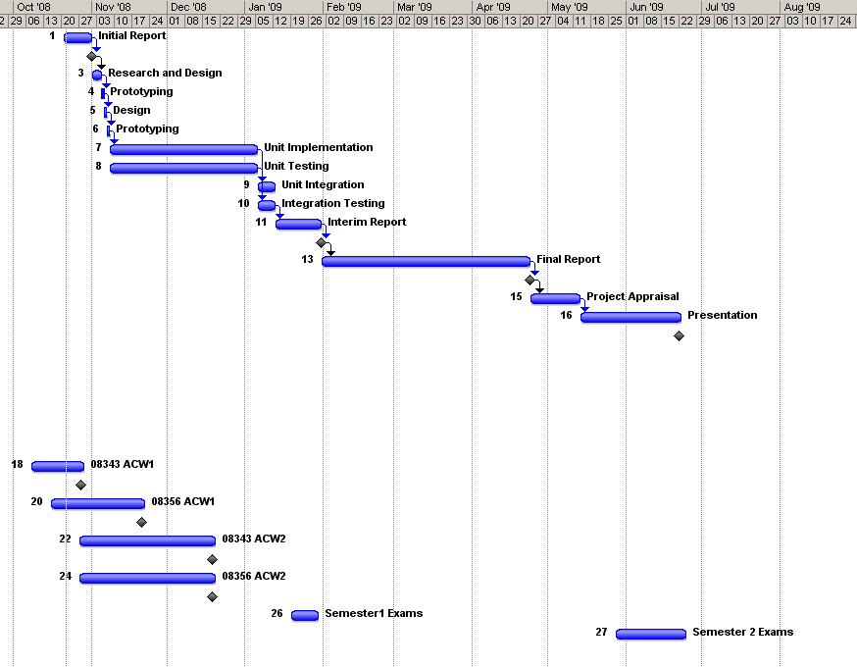

7.3 – Appendix III

7.4 – Appendix IV  
  
#1 Initial Report  
A report outlining the ultimate aims and goals of the project accompanied by a plan and timescale.  
***Duration – 9 days.***#2 Research and Design  
Continue with background research and design the system at a high level.  
***Duration – 3 days.***#3 Prototyping  
Produce a prototype of the project software and assess it externally.  
***Duration – 1 day.***#4 Design  
Go back to the initial design document/(s) and alter according to feedback.  
***Duration – 1 day.***#5 Prototyping  
Alter the prototype accordingly.  
***Duration – 1day.***#6 Unit Implementation  
Code the necessary units.  
***Duration – 42 days.***#7 Unit Testing  
Test all units extensively (white box and black box testing).  
***Duration – 42 days.***#8 Unit Integration  
Integrate the necessary units.  
***Duration – 5 days.***#9 Integration Testing  
Test the integration extensively (white box and black box testing).  
***Duration – 5 days.***  
  
#10 Interim Report  
The interim report is essentially a progress review including any and all revisions, updates, and modifications that need addressing at this stage of the project.  
***Duration – 14 days.***  
  
#11 Final Report  
The final report is and all encompassing document of everything that I have done and achieved during my final year project.  
***Duration – 60 days.***  
  
#12 Project Appraisal  
This is a review of how far successfully I have managed my project and my time.  
***Duration – 14 days.***#13 Presentation  
Preparing and executing the presentation of my final year project.  
***Duration – 28 days.***

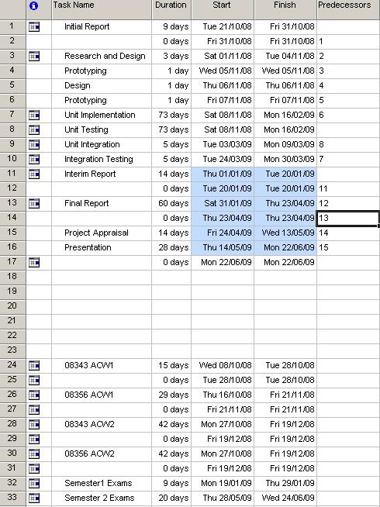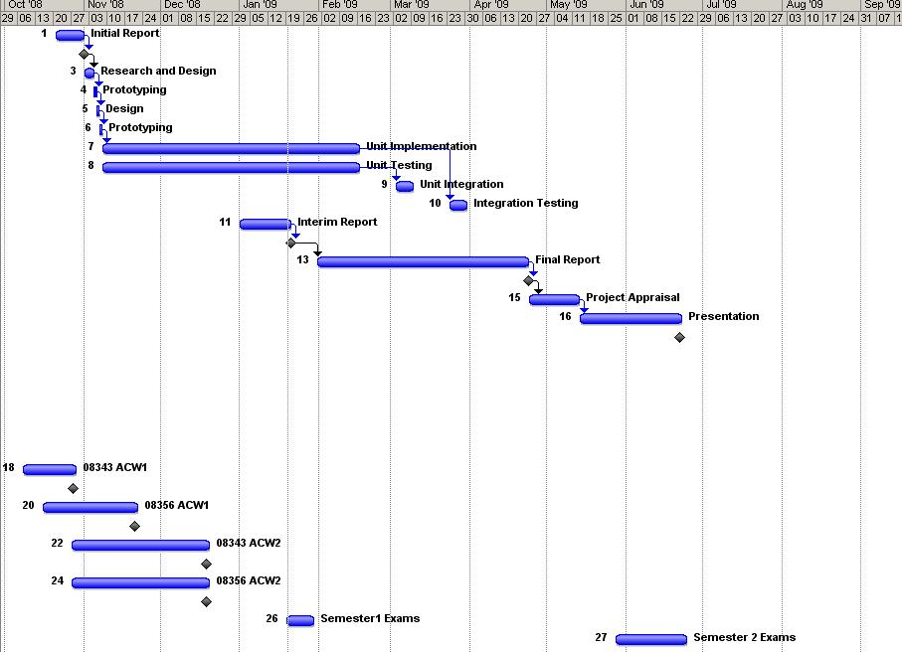

7.5 – Appendix V